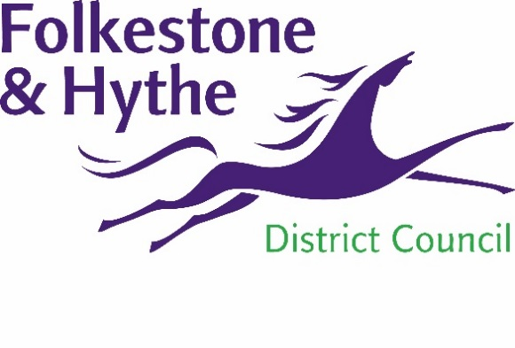
NEWS RELEASE
044
26 April 2019
Page 1 of 2

Exciting Plans Accelerated for Folkestone Town Centre

Folkestone & Hythe District Council will fast track their regeneration plans for the town centre, following the announcement today that the Folkestone Debenhams store will close.

The Council has been working for some time with Ellandi, the owners of Bouverie Place and the owner of the Debenhams store, on exciting plans to regenerate Folkestone town centre. The intention was to commence consultation on these plans in the coming months, but the announcement that Debenhams will be closing in 2020 has given the Council and their partners an opportunity to accelerate this work.

Over the coming weeks Folkestone & Hythe’s Accelerated Delivery Board, will share some of the early ideas for the future use of the Debenhams building and how it can continue to play a part in Folkestone's renaissance as a modern seaside town, with fantastic transport links and a thriving economy.

A spokesperson for Folkestone & Hythe District Council, said: "It has been clear for some time that Debenhams has been in difficulty nationwide. This decision is sadly due to the company's performance across the UK rather than the success or otherwise of the chain's Folkestone store.

"These regeneration plans will show how the town centre can continue to thrive and accommodate changes in shopping behaviour. In particular, we will demonstrate how new uses can make Folkestone an even more attractive and vibrant place to shop, visit, work and live."

Mark Robinson, Ellandi founder and Managing Director, added “With the new retailer replacing Peacocks, Bouverie Place will shortly once again be 100% occupied, showing how resilient Folkestone has been in a tough nationwide retail market. A number of major stakeholders have been liaising in respect of regeneration plans for the surrounding area and whilst it is sad to see a major High Street name in trouble, we aim to come forward shortly with exciting new plans to build on the success of Bouverie Place.”

ENDS

For more information please email communications@folkestone-hythe.gov.uk
Notes to Editors

The Accelerated Delivery Board is an association of strategic partners, who agree to work together to ensure delivery of the key projects that make up the district’s regeneration programme.

The board’s core purpose is to drive, facilitate and enable the continued economic growth of the district, informing and stimulating regeneration and renewal of action areas identified in the emerging Places and Policies Local Plan and adopted Core Strategy.

Board members:

Damian Collins MP MP for Folkestone and Hythe (Chair)
Cllr David Monk Leader of the Council, FHDC
Cllr John Collier Cabinet Member for the District Economy, FHDC
Cllr David Godfrey Cabinet Member for Special Projects, FHDC
Cllr Mark Dance Cabinet Member for Economic Development
John Bunnett Director of Place and Commercial, FHDC
Barbara Cooper Corporate Director Growth, Environment and Transport, KCC
Alastair Upton Chief Executive, Creative Foundation
Jo James Chief Executive of the Kent Invicta Chamber of
Commerce
Geoff Miles Chair of Kent and Medway Economic Partnership
Trevor Minter Director, Strandhouse
Chris Moore Head of Accelerated Delivery, Homes England
Mark Ellerby Senior Commercial Scheme Sponsor – Network Rail
Mark Robinson Founder and Managing Director, Ellandi

